Add / Remove Towns (Simple DOM Interaction)
You are given the following HTML code:
add-remove-towns.html
<!-- JS Advanced Exam @ SoftUni - 13-Nov-2016 -->
<!DOCTYPE html>
<html>
<head>
<meta charset="UTF-8">
<title>Add / Remove Towns</title>
<style>select, input { width: 100px }</style>
<script src="https://code.jquery.com/jquery-3.1.1.min.js"></script>
</head>
<body onload="attachEvents()">
<div>Towns</div>
<select id="towns" size="4">
<option>Sofia</option>
<option>Varna</option>
<option>Pleven</option>
</select>
<button id="btnDelete">Delete</button>
<div>
<input type="text" id="newItem" />
<button id="btnAdd">Add</button>
</div>
<script>
function attachEvents() {
// TODO: …
}
</script>
</body>
</html>
Your Task
Write the missing JavaScript code to make the [Add] and [Delete] buttons work as expected.
The [Add] button should append the text from the text box as a new item at the end of the list box and clear the input text box after that. If the textbox is empty, it should do nothing.
The [Delete] button should delete selected item from the list. If no item is selected, it should do nothing.
When an item is selected it has the property selected.
Examples
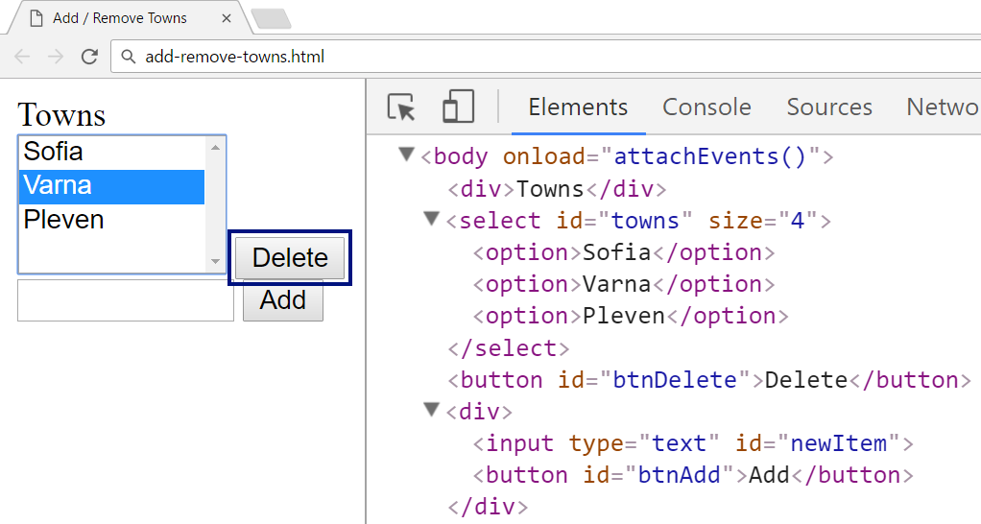
↓
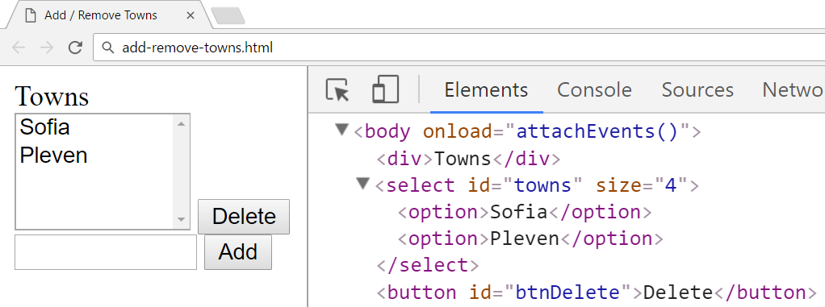
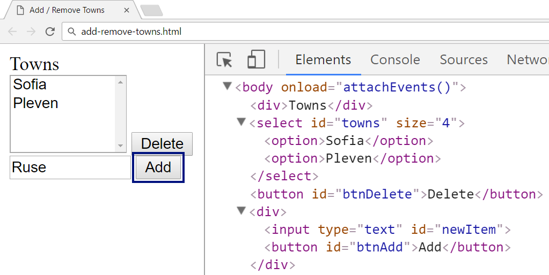
↓
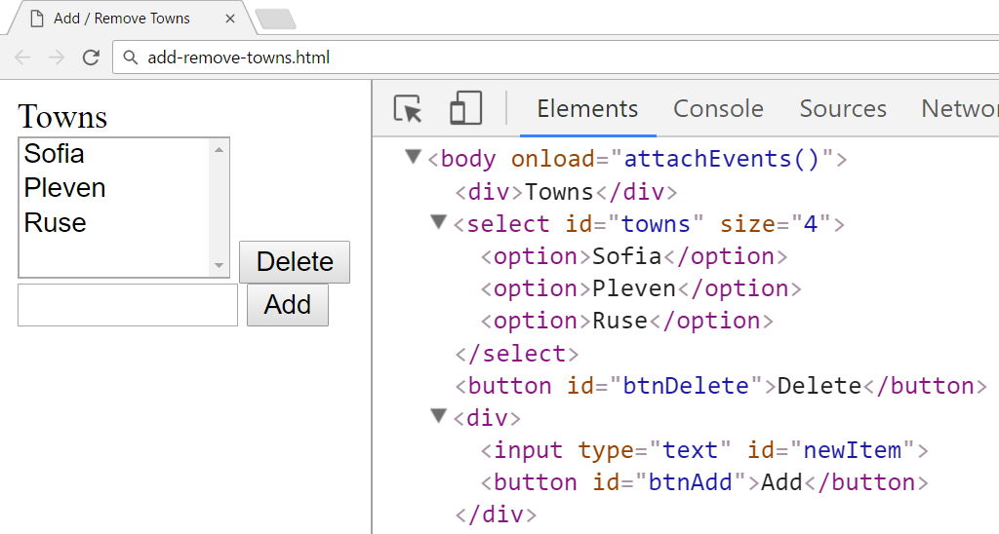
Submission
Submit your attachEvents function as “JavaScript code (DOM unit tests)”.

